1. Ubuntu

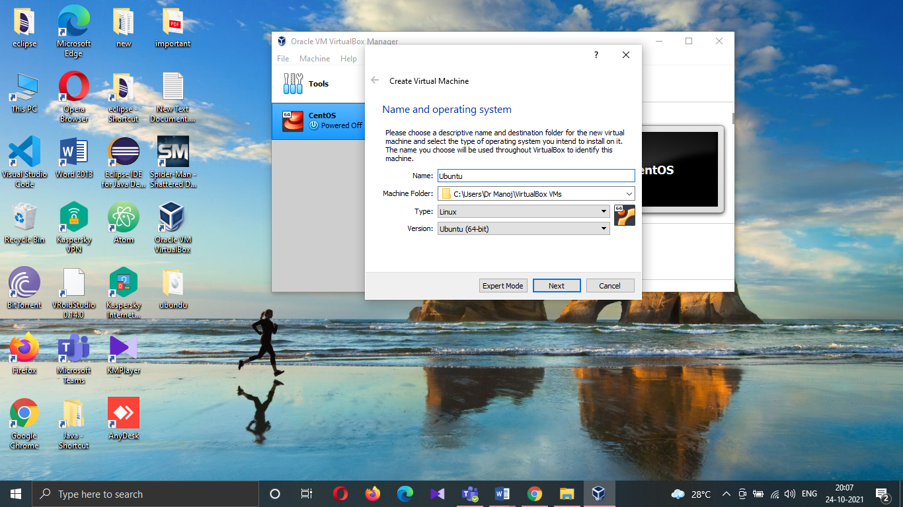

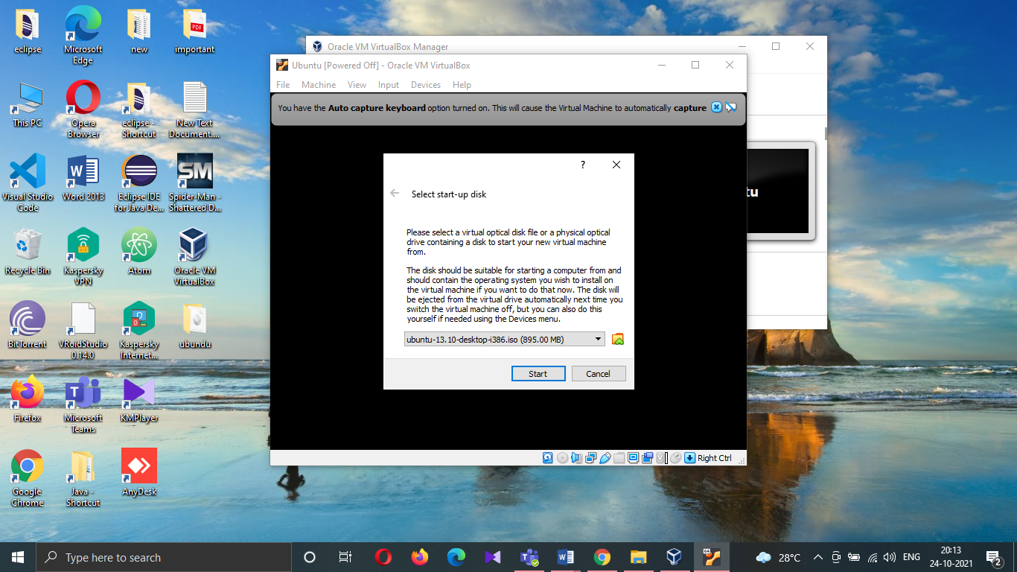

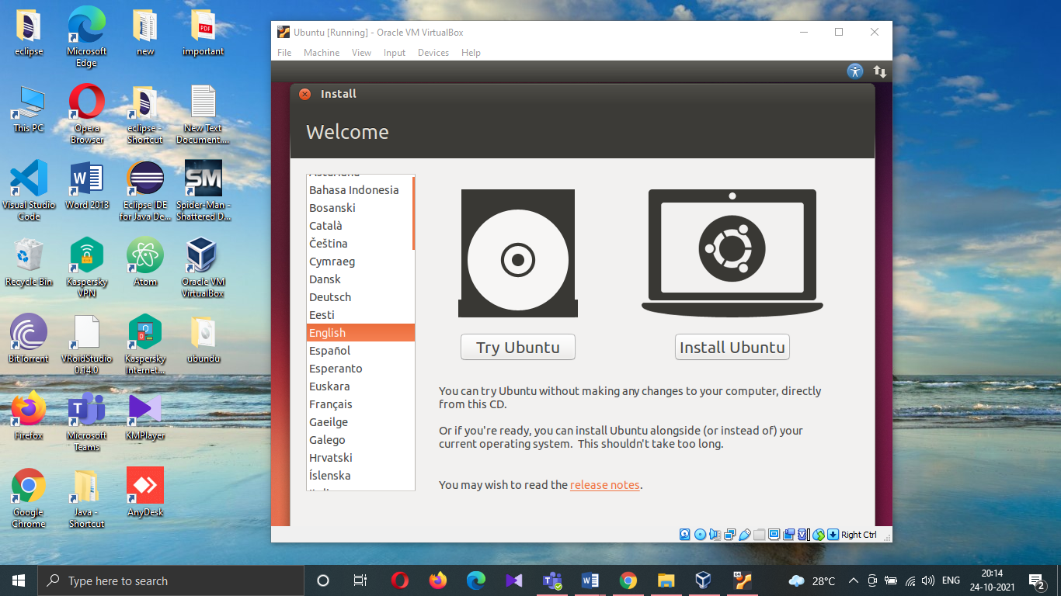

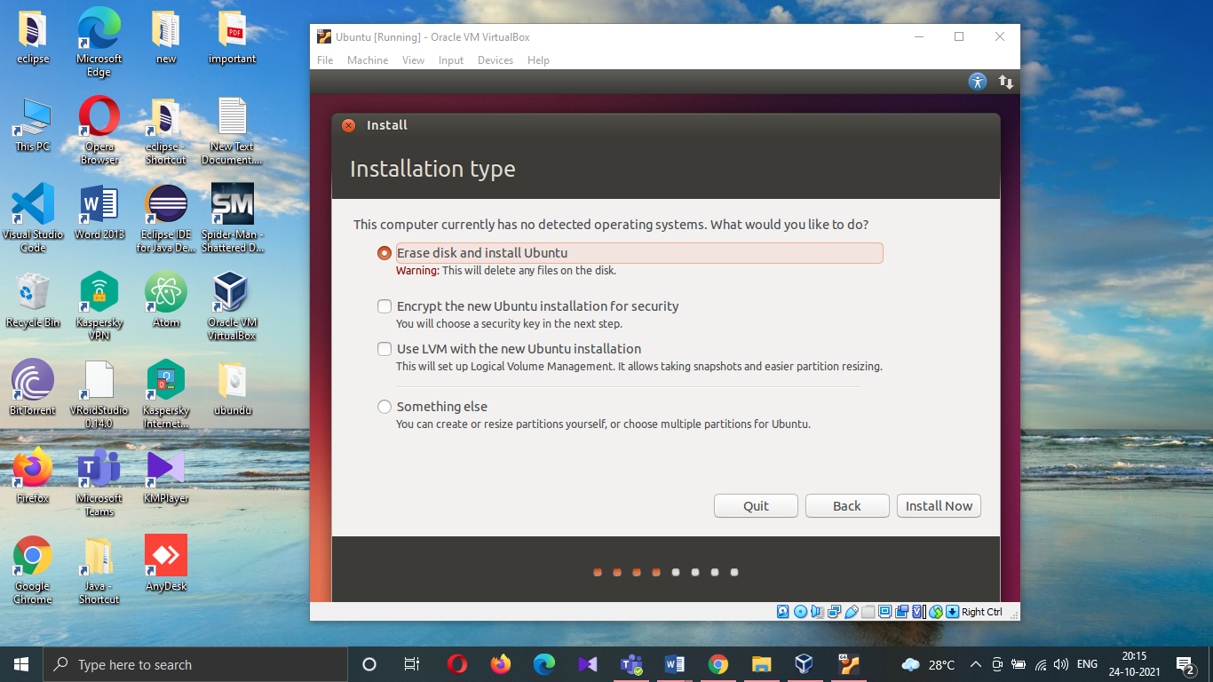

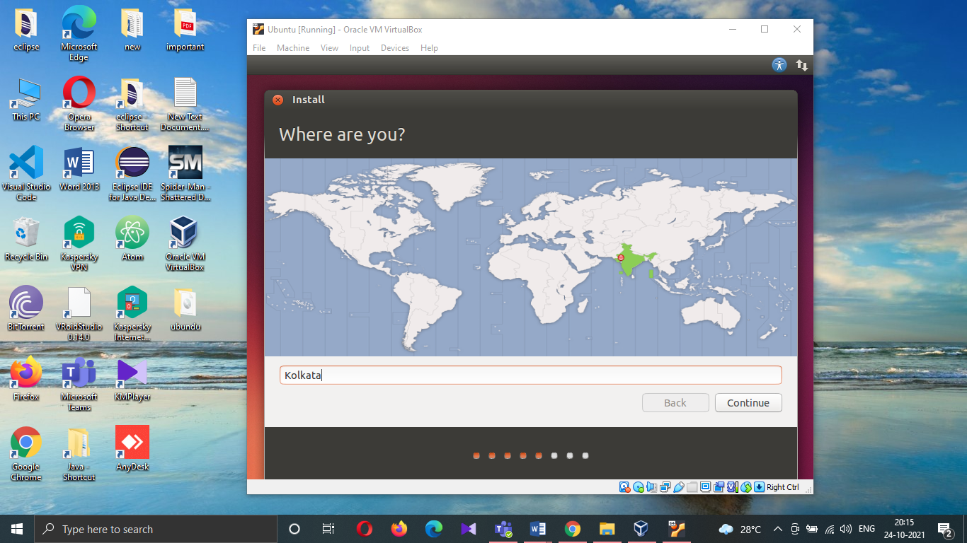

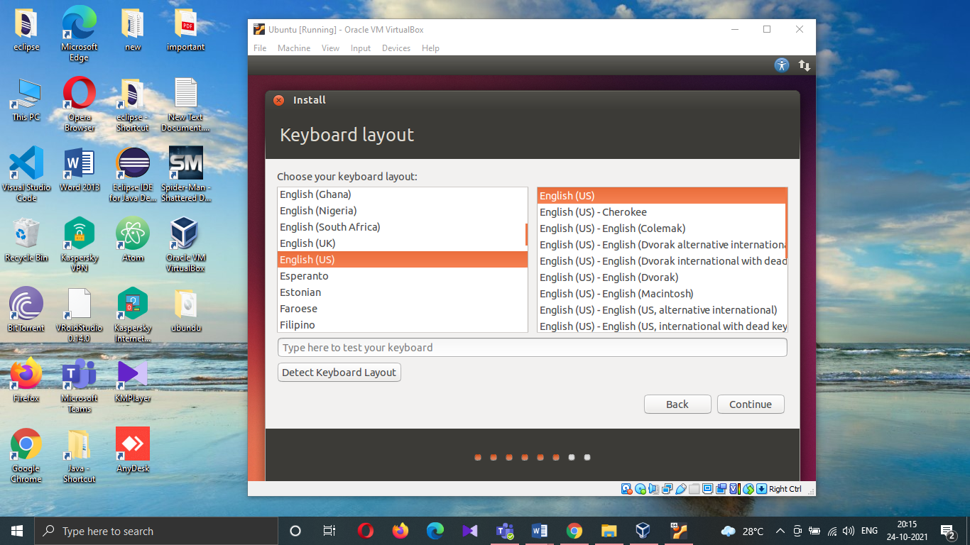

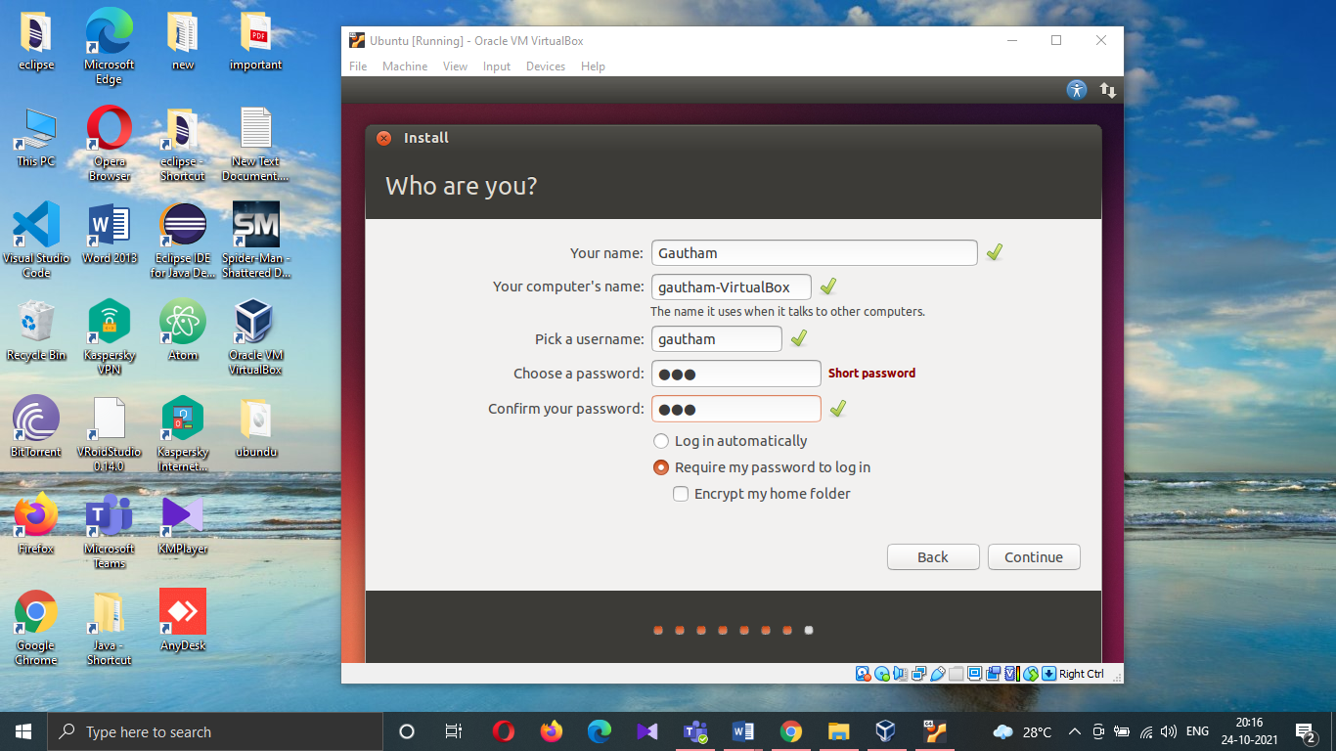

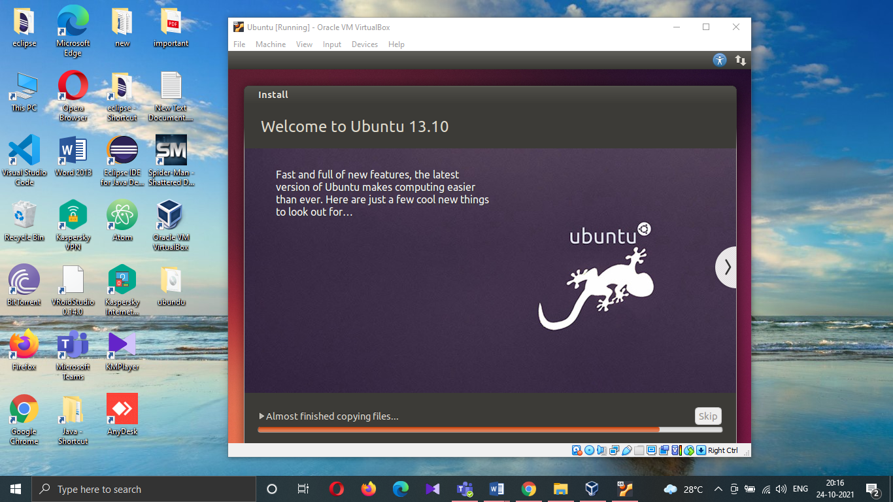

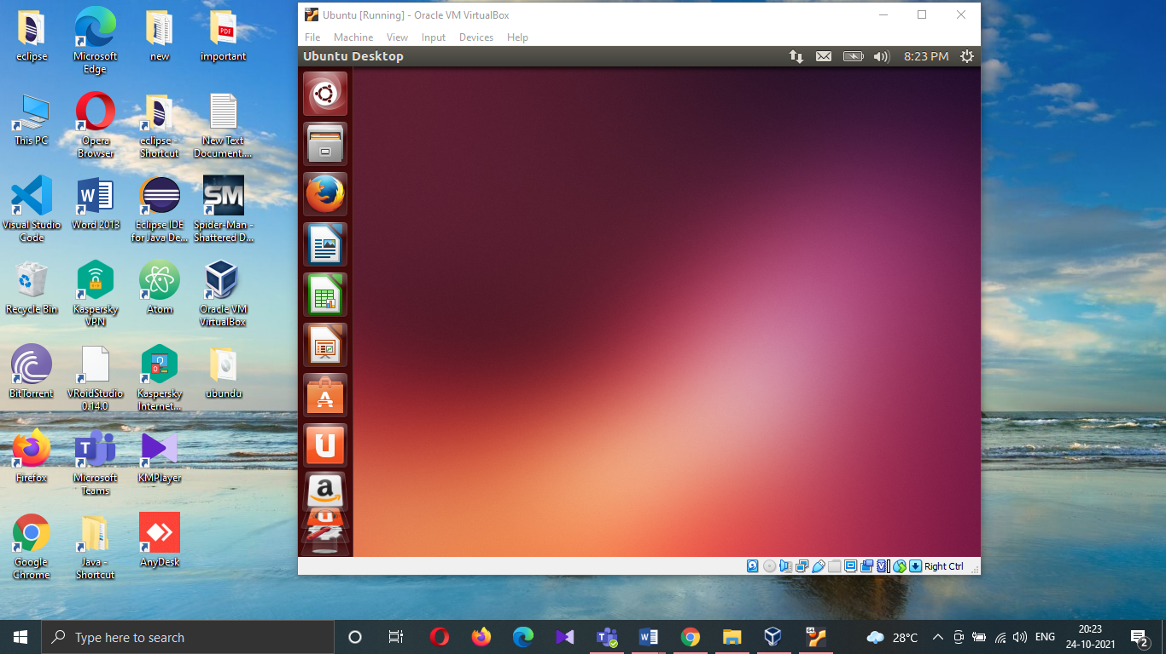

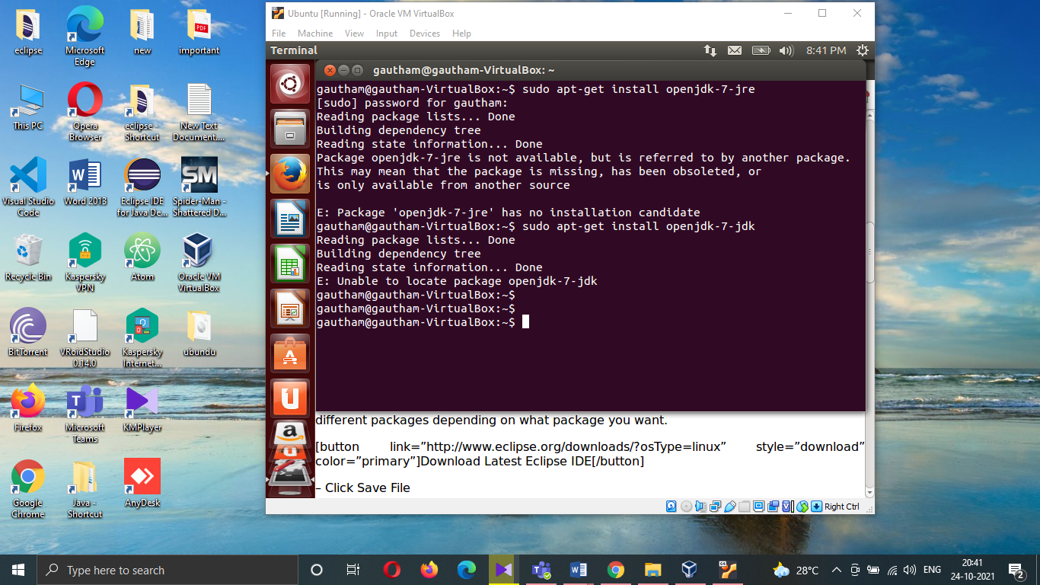

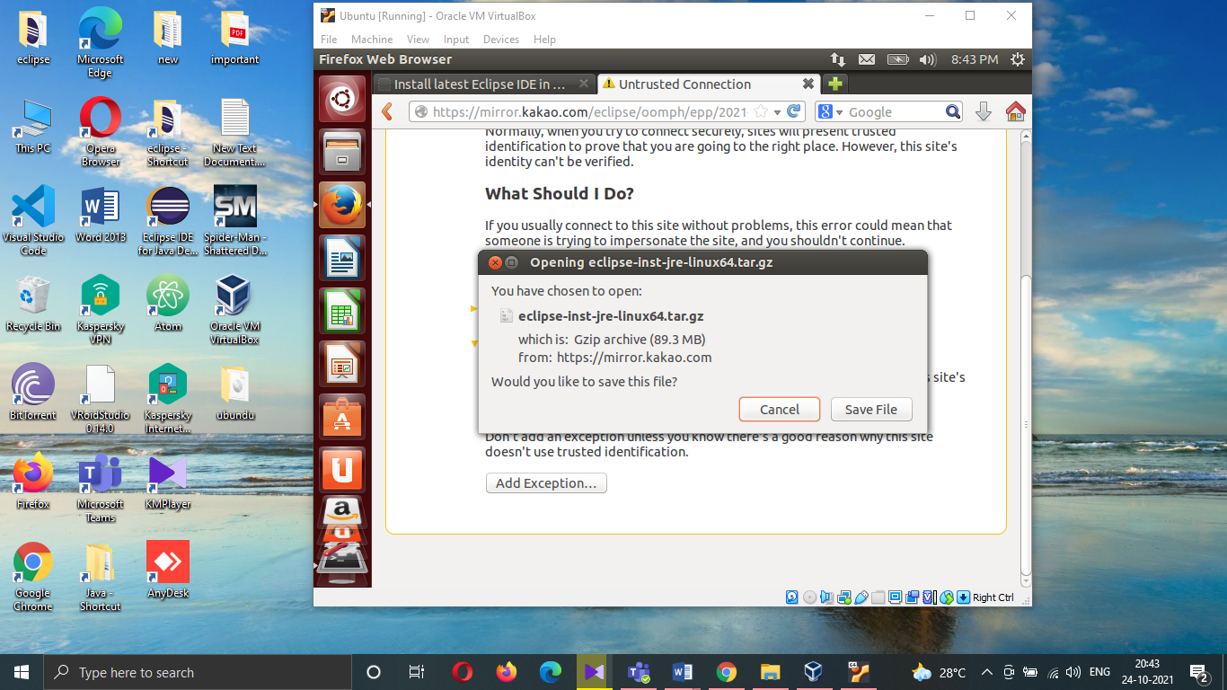

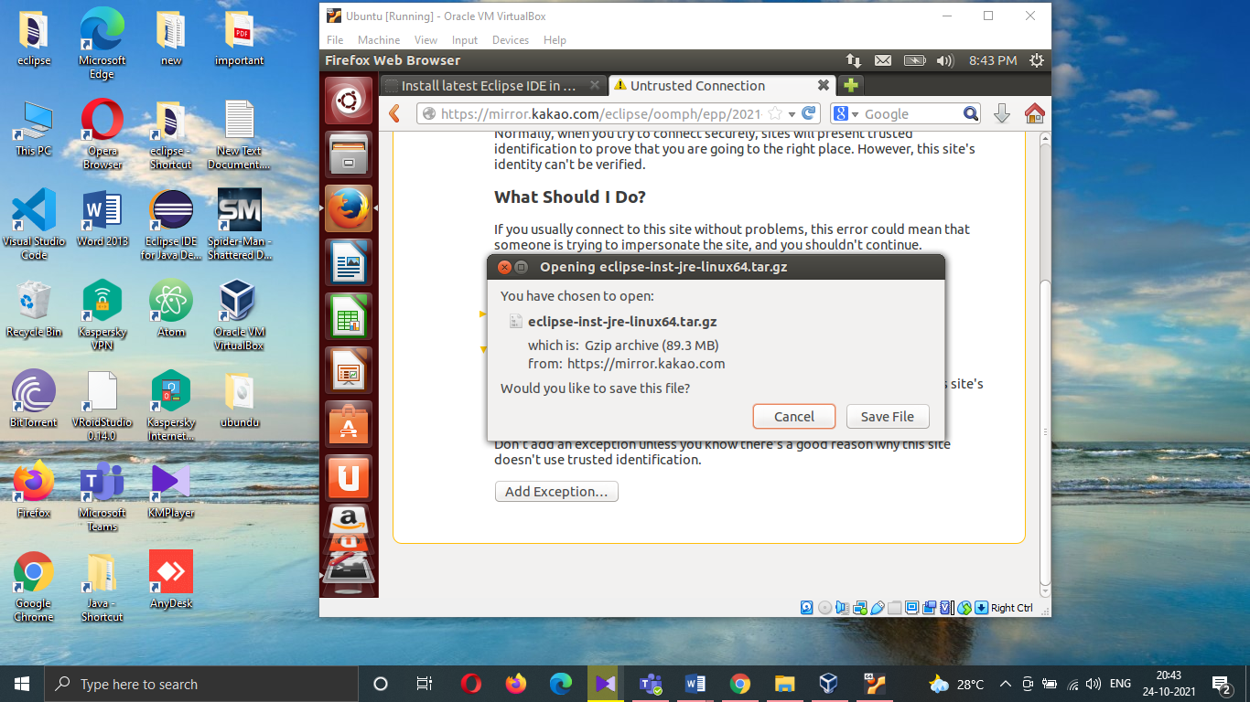

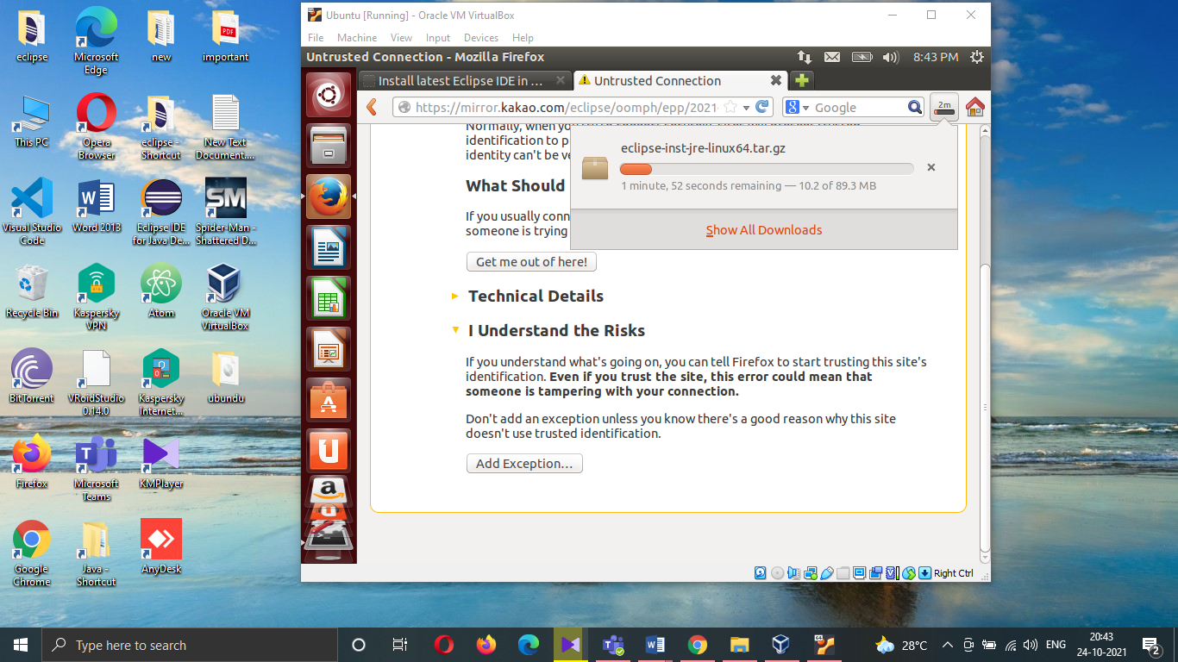

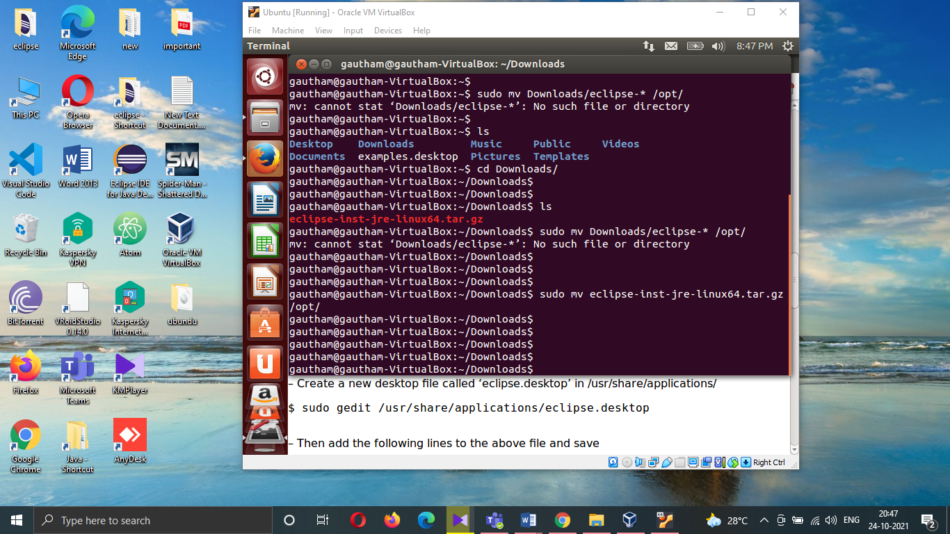

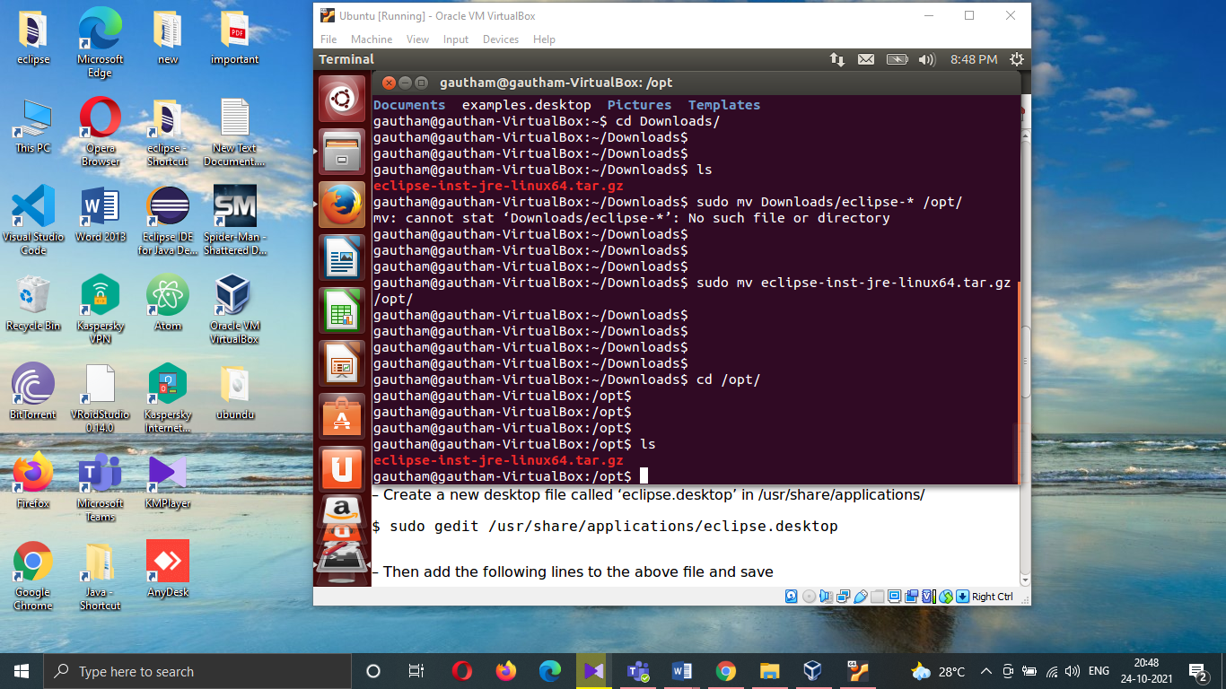

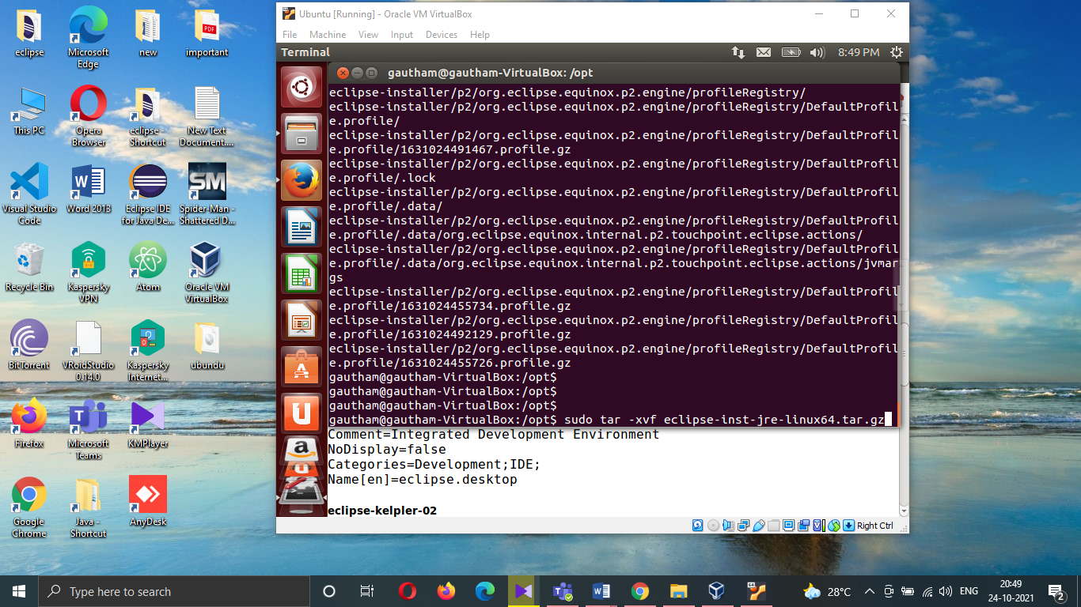

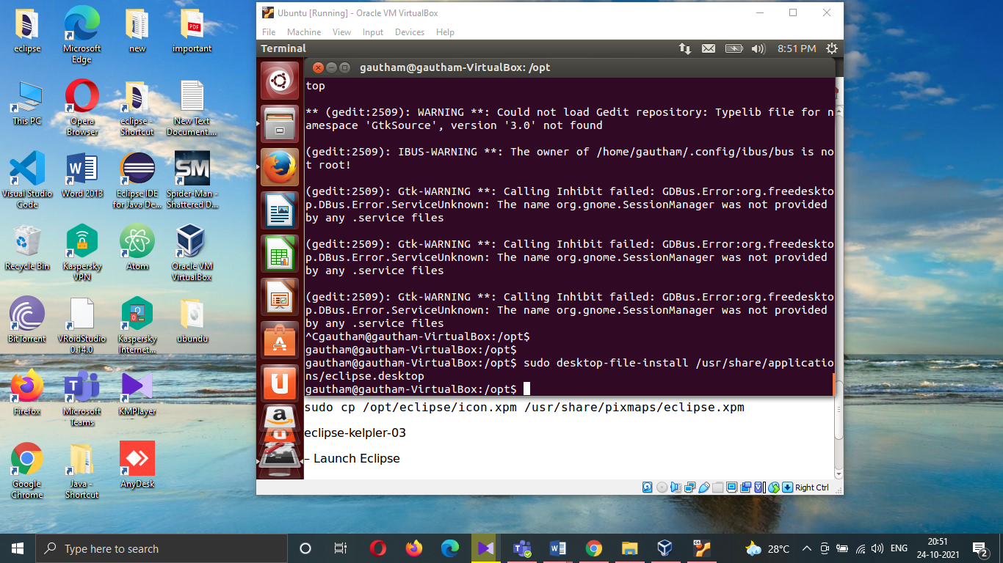

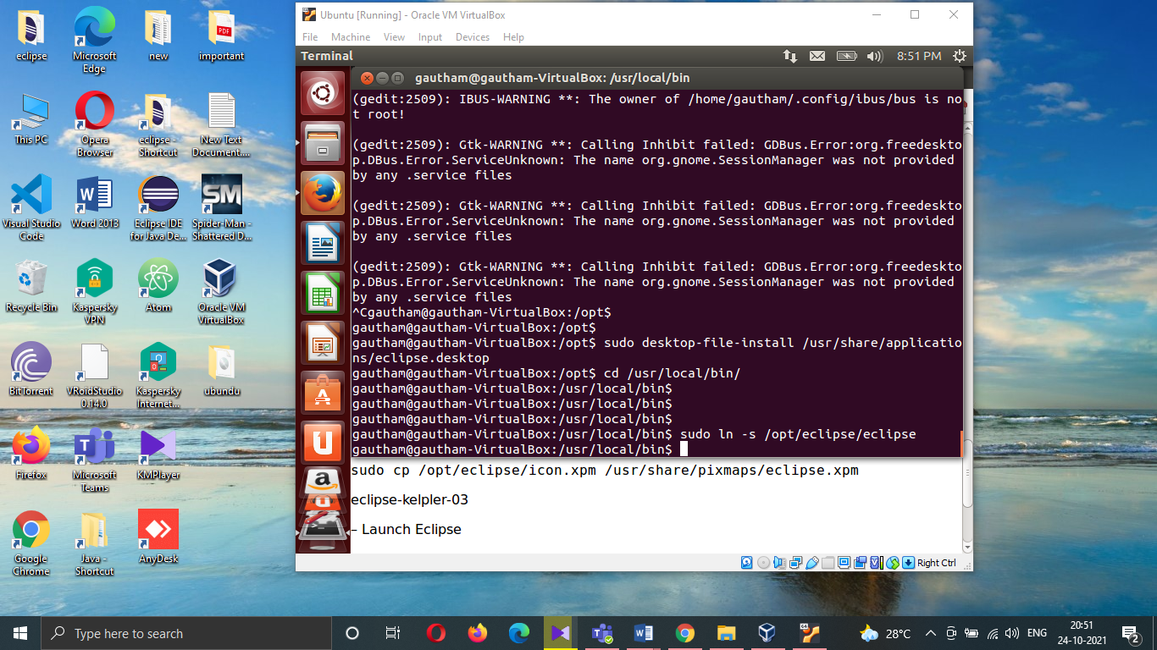

1. **Kernel:** it is the heart and core of an Operating System that manages operations of computer and hardware. It acts as a bridge between the user and the resources of the system by accessing various computer resources like the CPU, I/O devices and other resources.
2. It allow control of all the tasks of the system.
3. It’s a low level program interfacing with the hardware (CPU, RAM, disks) on top of which applications are running.
4. It is the core of the operating system.
5. It can performs memory management
6. It can performs process management.
7. Its types are – Monolithic Kernel, Micro kernel, Hybrid kernel, etc.
8. It is the inner layer of OS.

**Shell:** A shell is an environment or a special user program which provide an interface to user to use operating system services. It executes programs based on the input provided by the user.

1. It allows the users to communicate with the kernel.
2. It is a command line interpreter or CLI.
3. It is the interface between kernel and user.
4. It carries out commands on a group of files by specifying a pattern to match.
5. Shell commands includes ls, mkdir and many others can be used to complete the specific operation to the OS.
6. Its types are – Bourne Shell, C shell, Korn Shell, etc.
7. It is the outer layer of OS.
8. What is an OS?

An operating system (OS) is the program that, after being initially into the computer by a boot program, manages all of the other application programs in a computer. The programs make use of the operating system by making requests for services through a defined application program interface. In addition, users can interact directly with the operating system through a user interface, such as a command-line interface (CLI) or a graphical UI (GUI).

​​